SESSION 2022-23

B.sc Data Analytics (2nd SEM)

**ADVANCE EXCEL**

**Practical File**



**SUMITTED BY:- SUMITTED TO**:-

Rahul Sharma Mrs. Sheetal

ROLL NO. -40822025

|  |  |  |
| --- | --- | --- |
| **S.No.** | **INDEX** | **REMARK** |
| **1** | **Lab 1: Practice exercises: Data Validation, Creating Drop-down Lists, Using Formulas in Data Validation, Working with Data Validation, Advanced Conditional Formatting.** |  |
| **2** | **Lab 2: Practice exercises: Logical Functions : IF, Logical Functions II: AND, OR, Combining Logical Functions 1: IF, AND, OR, Combining Logical Functions II: Nested IFs, Handling Errors: IFERROR, IFNA,** |  |
| **3** | **Lab 3: Practice exercises: Introduction to Lookups: CHOOSE, Approximate Matches,Range VLOOKUP, Exact Matches: Exact Match VLOOKUP, Finding a Position: MATCH, Dynamic Lookups: INDEX, MATCH, Practice Challenge,** |  |
| **4** | **Lab 4: Practice exercises: Error Checking. Formula Calculation Options, Tracing Precedents and Dependents, Evaluate Formula, Watch Window, Protecting Workbooks and Worksheets** |  |
| **5** | **Lab 5: Practice exercises: Modelling Functions (SUMPRODUCT), Data Tables, Goal Seek,, Solver** |  |
| **6** | **Lab 6: Practice exercises: Record a Macro, Run your Macro, Edit a Macro, Working with Macros, Relative Reference Macros** |  |
| **7** | **Lab 7: Practice exercises: Spreadsheet Design Principles, Calculations, Formatting.Documentation, Interface and Navigation** |  |
| **8** | **Lab 8: Practice exercises: Tables and Structured Referencing. Using Functions to Sort Data, Introduction to Array Formulas** |  |
| **9** | **Lab 9: Practice exercises: Replace blanks with repeating values. Fix Dates (DATE. MONTH, YEAR, DAY. TEXT). Remove Unwanted Spaces (TRIM, CLEAN), Diagnostic Tools (ISNUMBER, LEN, CODE). Remove Unwanted Characters (SUBSTITUTE,CHAR, VALUE)** |  |
| **10** | **Lab 10: Practice exercises: Working with Dates (EOMONTH. EDATE WORKDAY INTL). Financial Functions (FV, PV, PMT), Loan Schedule (PMT, EDATE), Net Present Value and Internal Rate of Return (NPV, IRR), Depreciation Functions (SLN, SYD, DDB)** |  |
| **11** | **Lab 11: Practice exercises: INDIRECT, ADDRESS, Introduction to OFFSET. Solving**  **Problems with OFFSET** |  |
| **12** | **Lab 12: Practice exercise: Dashboard Design, Final Assignment** |  |

**Lab 1**



|  |  |  |  |
| --- | --- | --- | --- |
| Creating Drop -Down List. | | | |
|  |
| **I-D** | **City** | **Sales** | **Binary** |  |
| 1 | Delhi | N-A | 0 |  |
| 2 | Mumbai | Available | 1 |  |
| 3 | Karnatka | N-A | 0 |  |
| 4 | H.P | Available | 1 |  |
| 5 | UTT | N-A | 0 |  |
| 6 | UP | Available | 1 |  |
| 7 | Tamil Nadu | N-A | 0 |  |
| 8 | Bihar | Available | 1 |  |

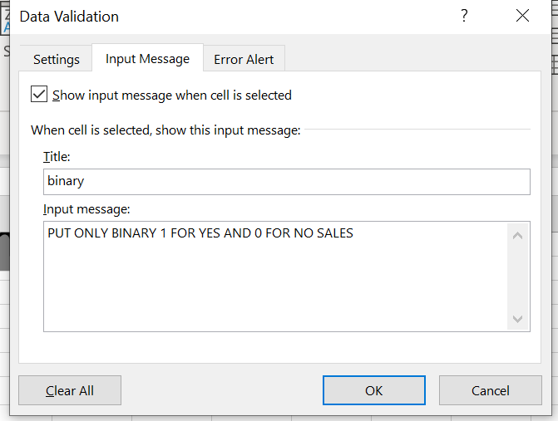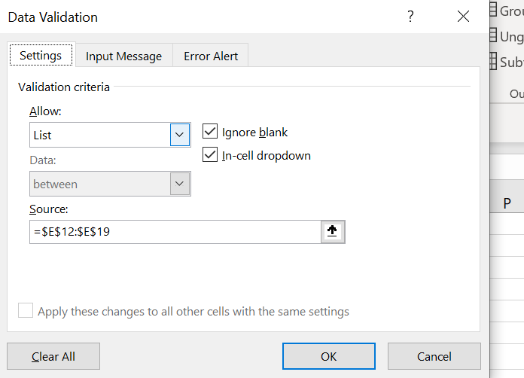

\

**3.Advance conditional Formatting**

|  |  |  |
| --- | --- | --- |
| **ROLL-NO** | **NAMES** | **MARKS** |
| 1 | RAHUL | 100 |
| 2 | SHEELA | 20 |
| 3 | DIMPLE | 40 |
| 4 | TANISH | 55 |
| 5 | KESHAV | 67 |
| 6 | BROCK | 89 |
| 7 | HATIM | 76 |
| 8 | DEEPAK | 45 |
| 9 | HITESH | 32 |
| 10 | RAHUL | 97 |
| 12 | SHEELA | 89 |
| 13 | TANISH | 43 |

|  |  |
| --- | --- |
| **mark down** | |
| SHEELA |  |
|  |  |
| STEP-1 |  |

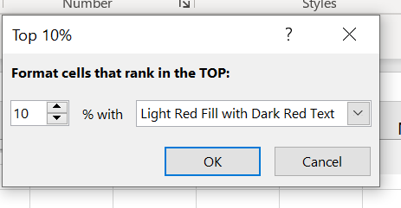

STEP-2

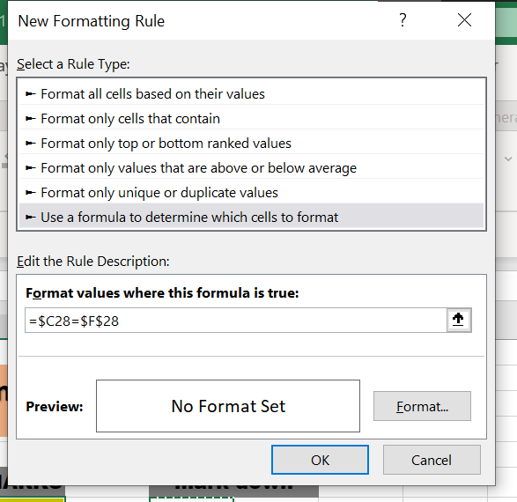

STEP-3

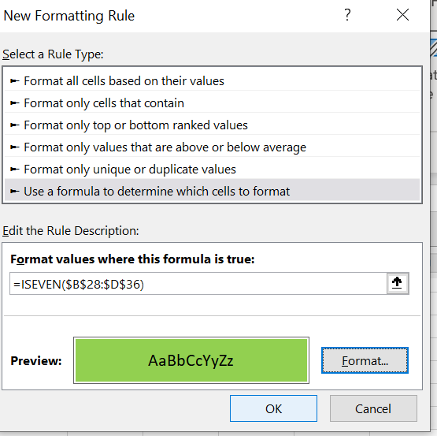

**4.ISERROR FUCTION()**

|  |  |  |
| --- | --- | --- |
| S.NO | VALUES | ISERROR |
| 1 | TRUE | FALSE |
| 2 | FALES | FALSE |
| 3 | TRUE | FALSE |
| 4 | FALSE | FALSE |
| 5 | #NAME? | TRUE |

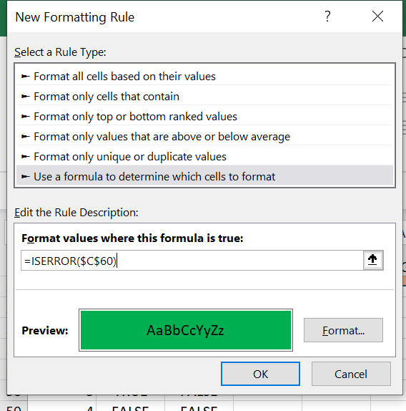

**LAB 2:**

**Logical Function :** "Logical functions in Excel are built-in functions that allow you to test and evaluate logical conditions, returning either TRUE or FALSE based on the outcome of the condition."

|  |  |  |  |  |
| --- | --- | --- | --- | --- |
| **IF FUNCTION()** | |  |  |  |
| **SR.N** | **NAME** | **POST** | **SALARY** | **LOGIC** |
| 1 | RAHUL | TYPIST | 35000 | NICE SALARY |
| 2 | KUMAR | DA | 40000 | NICE SALARY |
| 3 | SHAVAN | DS | 50000 | NICE SALARY |
| 4 | TEELA | HR | 10000 | NEED TO IMPROVE YOUR SKILLS |
| 5 | DEEPAK | MBA | 1200 | NEED TO IMPROVE YOUR SKILLS |
| 6 | SHIWANI | SPEAKER | 1333 | NEED TO IMPROVE YOUR SKILLS |
| 7 | DEVI | TESTER | 22333 | NEED TO IMPROVE YOUR SKILLS |
| 8 | TREE | WATCHER | 44555 | NICE SALARY |
| 9 | MANISH | TELLO | 35566 | NICE SALARY |
| 10 | TANISH | OPO | 3344 | NEED TO IMPROVE YOUR SKILLS |

HERE WE USE IF FUCTION ON SALARY IF SALARY IS BELOW 30000 ITS PRINT NEED TO IMPROVE YOUR SKILLS

|  |  |  |  |
| --- | --- | --- | --- |
| **AND FUNCTION()** | |  |  |
| **ENGLISH** | **HINDI** | **PASS/FAIL** | **RESLT** |
| 70 | 70 | TRUE | PASS |
| 50 | 50 | TRUE | PASS |
| 80 | 20 | FALSE | FAIL |
| 60 | 44 | TRUE | PASS |
| 50 | 39 | TRUE | PASS |

RED AREA SHOW TRUE FOR PASSING THE BOTH EXAM

|  |  |  |
| --- | --- | --- |
| **IFERROR ()** | | |
|  |  |  |
| **QUANTITY** | **PRICE** | **TOTAL** |
| 2 | 100 | 200 |
| 34 | 6 | 204 |
| 5 | 6 | 30 |
| 6 | 45 | 270 |
| 6 | 3000 | 18000 |
| 4 | 766 | 3064 |
| 5 | 5 | 25 |
| 6 | 4443 | 26658 |
| 0 | 433 | 0 |
| 0 | F34545 | ERROR OCCURRED |
| 7 | 666 | 4662 |

**LAB 3:**

INTRODUCTION OF LOOKUPS

|  |  |  |  |  |  |
| --- | --- | --- | --- | --- | --- |
| ***1.VLOOKUP FUNCTION()*** | | |  |  |  |
|  | | |  |  |  |
| **Employee ID** | | | **Last Name** | **First Name** | **Pay** |
| 110608 | | | SHARMA | RAHUL | $ 4,546 |
| 253072 | | | SHARMA | AMAN | $ 4,354,543 |
| 352711 | | | SHARMA | ANISH | $ 455 |
| 391006 | | | SHARMA | TANISH | $ 4,524,452 |
| 392128 | | | SHARMA | VIKRAM | $ 45,424 |
| 549457 | | | SHARMA | DEEPAK | #N/A |
| 580622 | | | SHARMA | ADARSH | #N/A |
| 602693 | | | SINGH | FOOLL | $ 664 |
| 611810 | | | SHARMA | LOOP | $ 34,543 |
| 612235 | | | SHARMA | TULI | $ 5,435 |
| 795574 | | | SHARMA | KARTILK | #N/A |
| 830385 | | | SHARMA | PREET | #N/A |
| 990678 | | | SHARMA | BIHARI | #N/A |
| **Employee ID** | **Pay** |
| 990678 | $45,000 |
| 830385 | $500,000 |
| 795574 | $666,666 |
| 580622 | $2,433,432 |
| 549457 | $34,234 |
| 392128 | $45,424 |
| 391006 | $4,524,452 |
| 352711 | $455 |
| 253072 | $4,354,543 |
| 612235 | $5,435 |
| 611810 | $34,543 |
| 602693 | $664 |
| 110608 | $4,546 |

|  |  |  |  |  |  |  |  |  |  |  |  |  |  |  |
| --- | --- | --- | --- | --- | --- | --- | --- | --- | --- | --- | --- | --- | --- | --- |
| **2.HLOOKUP FUNCTION ()** | | |  | |  |  |  |  |  |  |  |  |  |  |
| **Employee ID** | **101** | **102** | | **103** | | | | **104** | **105** | **106** | **107** | **108** | **109** | **110** |
| **Employee Name** | RAHUL | ANISH | | AMAN | | | | TANISH | MOLI | TAPSITE | KV | APS | DESI BALAK | MOHAN |
| **Department** | HR | CA | | CS | | | | HR | IT | CA | FINANCE | JOURNALISM | REOTER | SPORTSMAN |
| **Salary** | 50000 | 55000 | | 60000 | | | | 65000 | 70000 | 75000 | 80000 | 85000 | 90000 | 95000 |
| **Bonus** | 2000 | 2500 | | 3000 | | | | 3500 | 4000 | 4500 | 5000 | 5500 | 6000 | 6500 |
| **Total Pay** | 52000 | 57500 | | 63000 | | | | 685000 | 74000 | 79500 | 85000 | 90500 | 96000 | 101500 |

|  |  |  |
| --- | --- | --- |
| |  | | --- | | Answer | |  |
|  |  |
| Employee id | names |
| 101 | RAHUL |
| 3.XLOOKUP FUNCTION() |  |
| Age | Name |
| 13 | JATIN |
| 33 | MONY |
| 44 | KARTIK |
| 53 | DEEPKA |
| 60 | TANISH |
| 21 | ANISH |

|  |  |
| --- | --- |
| NAME | DEEPKA |
| AGE | 53 |

|  |  |  |  |
| --- | --- | --- | --- |
| **4.MATCH ()** |  |  |  |
| **TOP PRODUCTS** |  | TOP PRODUCT | POSTION |
| MOBILE |  | CAMERA | 2 |
| CAMERA |  |  |  |
| WATCHES |  |  |  |
| SHOES |  |  |  |

**Lab 4:**

|  |  |
| --- | --- |
| **ERROR CHECK** | |
|  |  |
| ERROR |  |
| #NAME? |  |
| #NAME? |  |
| #NAME? |  |
| #NAME? |  |

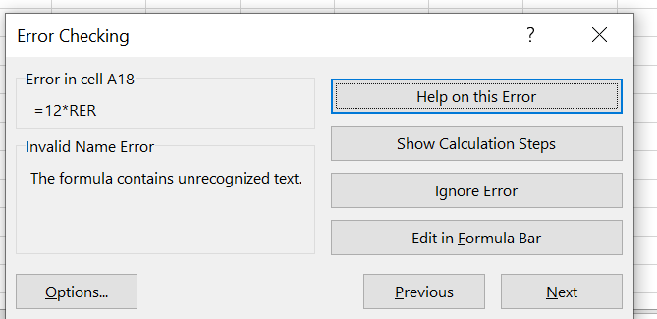

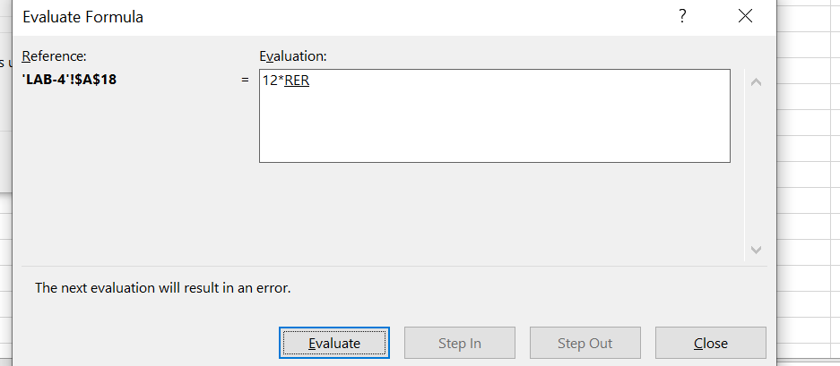

|  |  |  |  |  |  |  |
| --- | --- | --- | --- | --- | --- | --- |
| **2. Formula Calculation Option** | | | | | | |
|  |
|  |  |  |  |  |  |  |  |
| **First Name** | **Employee ID** | **Pay** |  |  |  |  |  |
| RAHUL | 990678 | $45,000 |  |  |  |  |  |
| AMAN | 830385 | $500,000 |  |  |  |  |  |
| ANISH | 795574 | $666,666 |  |  |  |  |  |
| TANISH | 580622 | $2,433,432 |  |  |  |  |  |
| VIKRAM | 549457 | $34,234 |  |  |  |  |  |
| DEEPAK | 392128 | $45,424 |  |  |  |  |  |
| ADARSH | 391006 | $4,524,452 |  |  |  |  |  |
| FOOLL | 352711 | $455 |  |  |  |  |  |
| LOOP | 253072 | $4,354,543 |  |  |  |  |  |
| TULI | 612235 | $5,435 |  |  |  |  |  |
| KARTILK | 611810 | $34,543 |  |  |  |  |  |
| PREET | 602693 | $664 |  |  |  |  |  |
| BIHARI | 110608 | $4,546 |  |  |  |  |  |

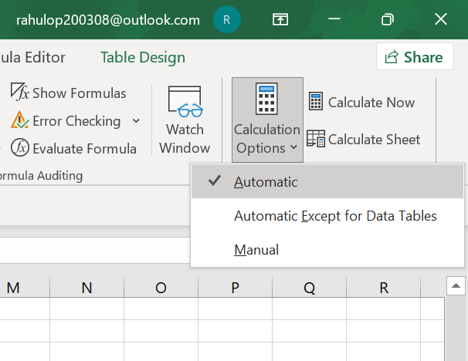

|  |
| --- |
| **3. TRACE PRECEDENTS & TRACE DEPENDENTS** |
|  |

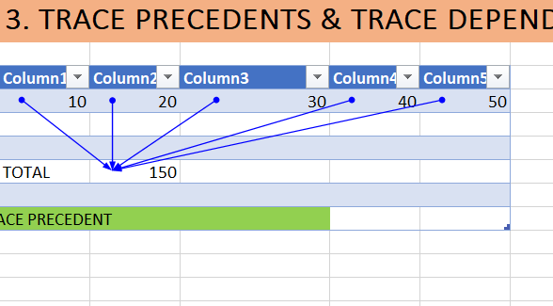

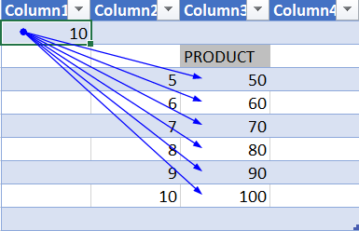

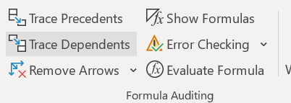

|  |
| --- |
| **4. Evaluate Formula** |
|  |

|  |  |
| --- | --- |
| MARKS |  |
| 10 |  |
| 20 |  |
| 30 |  |
| 40 |  |
| 50 |  |
| 150 | TOTAL |

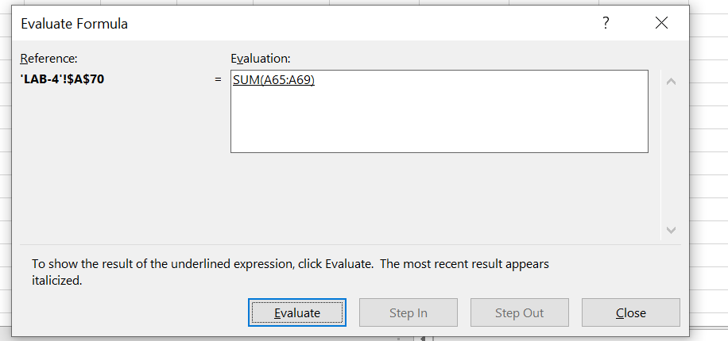

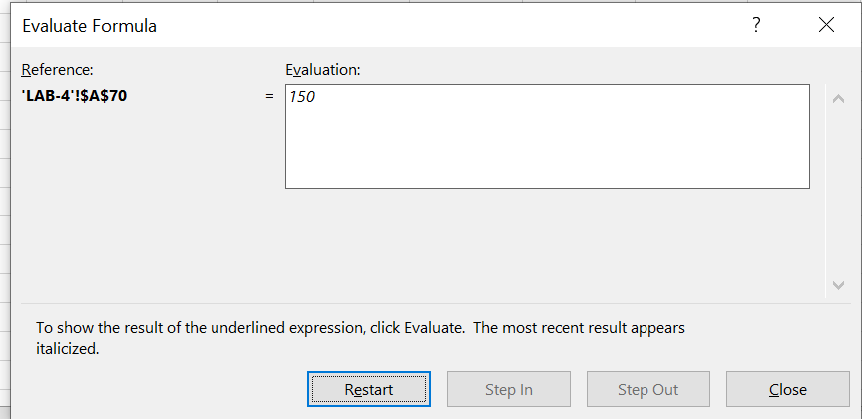

|  |
| --- |
| **5. Watch Window** |
|  |

|  |  |
| --- | --- |
| MARKS |  |
| 10 |  |
| 20 |  |
| 30 |  |
| 40 |  |
| 50 |  |
| 150 | TOTAL |

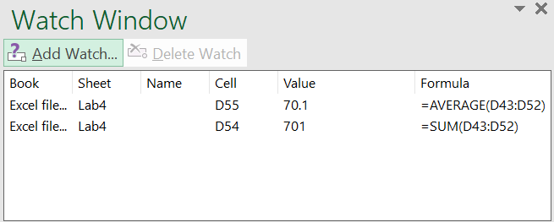

|  |
| --- |
| **6. Protecting Workbook and Worksheet** |
|  |

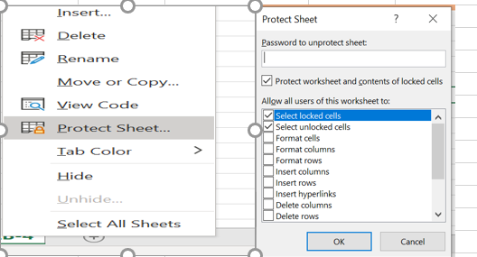

**LAB 5:**

Modelling Functions :

|  |
| --- |
| **1. Sumproduct** |
|  |

|  |  |  |  |
| --- | --- | --- | --- |
| BOOKS | PRICE | OTY |  |
| MS EXCEL | 130 | 10 |  |
| MS WORD | 90 | 15 |  |
| MS ACCES | 80 | 20 |  |
| MS POWER | 110 | 10 |  |
| PS 4 | 65 | 12 |  |
|  |  |  |  |
|  | **TOTAL PRICE** |  | 6130 |

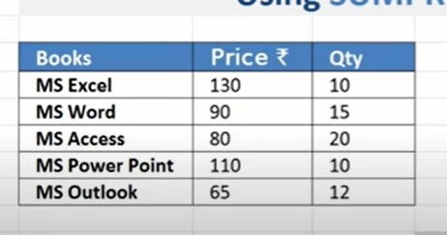

|  |
| --- |
| **2. GoalSeek** |
|  |

|  |  |  |  |  |  |  |
| --- | --- | --- | --- | --- | --- | --- |
| PRINCIPAL AMOUNT | -2.23295258 |  |  |  | OUR TARGET IS 40% |  |
| DURATION IN YEAR | 7 |  |  |  |  |  |
| RATE OF INTEREST | 6% |  |  |  |  |  |
|  | $0.40 |  |  |  |  |  |

|  |
| --- |
| 4.SOLVER |
|  |

|  |  |  |  |  |  |
| --- | --- | --- | --- | --- | --- |
| **SUDUKO WITH SOLVER** |  | 8 | 3 | 4 | 15 |
|  |  | 1 | 5 | 9 | 15 |
|  |  | 6 | 7 | 2 | 15 |
|  | 15 | 15 | 15 | 15 | 15 |

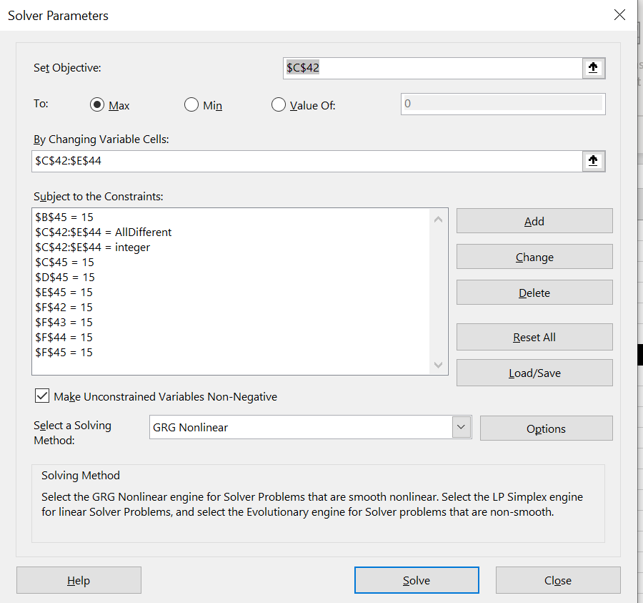

**LAB 6:**

Working with Macros :

|  |  |  |  |
| --- | --- | --- | --- |
| SUM | MAX | MIN |  |
| 22 | 34 | 3 |  |
| 3 | 434 | 43 |  |
| 34 | 3 | 434 |  |
| 34 | 3 | 3 |  |
| 5 | 434 | 34 |  |
| 3434 |  | 34 |  |
| 43443 | 3456 | 76 |  |
| 46975 | 3456 | 3 |  |

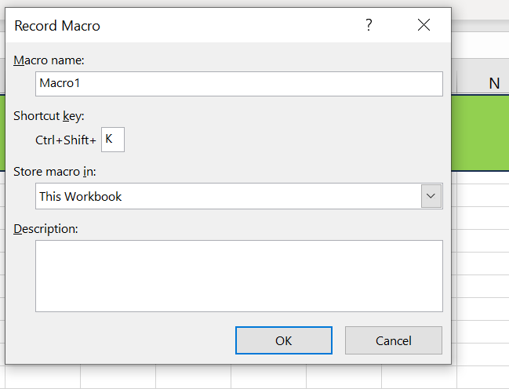

**LAB 7:**

**Spreadsheet Design Principles:**

|  |  |  |  |  |  |  |  |  |  |
| --- | --- | --- | --- | --- | --- | --- | --- | --- | --- |
| **SNO** | **2.Gender** | **3. Year of Study** | **4. Branch** | **1. Type of Schooling till 10th Grade:** | **2. Percentage in Class 10th?** | **3. Location of Class 10th School:** | **4. Type of Schooling for class 12th:** | **5. Percentage in Class 12th?** | **6. Location of Class 12th School:** |
| 1 | Female | Second | CSIT | Schooling with Tuitions | >= 90% | City | Schooling with Tuitions | >=90% | City |
| 2 | Male | Second | CSIT | Normal Schooling | >= 90% | City | Coaching Based Schools | >=90% | City |
| 3 | Male | Second | CSIT | Normal Schooling | >=70% and <80% | City | Normal Schooling | >=80% and <90% | City |
| 4 | Male | Second | CSIT | Normal Schooling | >=70% and <80% | City | Normal Schooling | >=80% and <90% | City |
| 5 | Male | Second | CSIT | Normal Schooling | >= 90% | Town | Normal Schooling | >=90% | Town |
| 6 | Female | Second | CSIT | Schooling with Tuitions | >=80% and <90% | Town | Schooling with Tuitions | >=90% | Town |
| 7 | Male | Second | CSIT | Normal Schooling | >= 90% | City | Normal Schooling | >=80% and <90% | City |
| 8 | Male | Second | CSE | Normal Schooling | <60% | Village | Distance learning | >=60% and <70% | Village |
| 9 | Male | Second | IT | Schooling with Tuitions | >= 90% | Town | Schooling with Tuitions | >=90% | Town |
| 10 | Female | Second | CSE | Normal Schooling | >= 90% | City | Coaching Based Schools | >=80% and <90% | City |
| 11 | Female | Second | CSE | Schooling with Tuitions | >= 90% | Town | Schooling with Tuitions | >=90% | Town |
| 12 | Female | Second | CSIT | Normal Schooling | >=80% and <90% | Town | Normal Schooling | >=90% | City |
| 13 | Male | Second | CSIT | Normal Schooling | >=80% and <90% | City | Schooling with Tuitions | >=80% and <90% | City |
| 14 | Male | Second | CSE | Normal Schooling | >=80% and <90% | City | Normal Schooling | >=90% | City |
| 15 | Female | Second | CSE | Normal Schooling | >= 90% | Town | Schooling with Tuitions | >=80% and <90% | Town |
| 16 | Male | Second | CS | Normal Schooling | >=80% and <90% | Village | Normal Schooling | >=80% and <90% | Village |
| 17 | Female | Second | CSE | Schooling with Tuitions | >=80% and <90% | City | Schooling with Tuitions | >=90% | City |
| 18 | Male | Second | CSE | Normal Schooling | >= 90% | City | Normal Schooling | >=90% | City |
| 19 | Female | Second | IT | Schooling with Tuitions | >=70% and <80% | Village | Schooling with Tuitions | >=80% and <90% | Town |
| 20 | Male | Second | IT | Normal Schooling | >=80% and <90% | City | Normal Schooling | >=80% and <90% | City |
| 21 | Female | Second | CSE | Normal Schooling | >= 90% | Town | Schooling with Tuitions | >=90% | City |
| 22 | Male | Second | ECE | Schooling with Tuitions | >=80% and <90% | City | Schooling with Tuitions | >=90% | City |
| 23 | Male | Second | CSE | Schooling with Tuitions | >=80% and <90% | Village | Schooling with Tuitions | >=70% and <80% | Village |
| 24 | Male | Second | CSE | Normal Schooling | >=80% and <90% | Town | Normal Schooling | >=80% and <90% | Town |
| 25 | Male | Second | CSIT | Normal Schooling | >= 90% | Town | Normal Schooling | >=80% and <90% | Town |

**LAB 8:**

USING SUM,AVERAGE,COUNT,SUMIF,COUNTIF,AVERAGE IFUSING SUM,AVERAGE,COUNT,SUMIF,COUNTIF,AVERAGE IF

|  |  |  |  |  |  |  |
| --- | --- | --- | --- | --- | --- | --- |
| **Product ID** | **Region** | **Cost pet Unit** | **No. of units** | **Total Cost** | **Discount** | **Sales** |
| 1 | East | ₹ 50 | 2 | ₹ 100 | 0.05 | ₹ 95 |
| 2 | West | ₹ 70 | 3 | ₹ 210 | 0.05 | ₹ 200 |
| 3 | South | ₹ 10 | 5 | ₹ 50 | 0.05 | ₹ 48 |
| 4 | East | ₹ 40 | 2 | ₹ 80 | 0.05 | ₹ 76 |
| 5 | West | ₹ 15 | 4 | ₹ 60 | 0.05 | ₹ 57 |
| 6 | South | ₹ 10 | 1 | ₹ 10 | 0.05 | ₹ 10 |
| 7 | East | ₹ 30 | 3 | ₹ 90 | 0.05 | ₹ 86 |
| 8 | East | ₹ 35 | 5 | ₹ 175 | 0.05 | ₹ 166 |
| 9 | South | ₹ 84 | 5 | ₹ 420 | 0.05 | ₹ 399 |
| 10 | East | ₹ 82 | 6 | ₹ 492 | 0.05 | ₹ 467 |
| 11 | West | ₹ 66 | 7 | ₹ 462 | 0.05 | ₹ 439 |
| 12 | North | ₹ 21 | 3 | ₹ 63 | 0.05 | ₹ 60 |
| 13 | West | ₹ 32 | 5 | ₹ 160 | 0.05 | ₹ 152 |
| 14 | North | ₹ 34 | 6 | ₹ 204 | 0.05 | ₹ 194 |

|  |  |  |  |  |  |  |
| --- | --- | --- | --- | --- | --- | --- |
| Sum | ₹ 2,447 |  |  |  |  |  |
| Average | 174.8 |  |  |  |  |  |
| Count | 14 |  |  |  |  |  |
| SumIF | 847.4 | SUM OF SALES OF WEST REGION | | | |  |
| AverageIF | 211.85 | AVERAGE OF SALES OF WEST REGION | | | |  |
| CountIF | 4 | COUNT OF WEST REGION | | |  |  |

**LAB 9:**

**1. Remove Unwanted Space (CLEAN,TRIM)**

|  |  |  |
| --- | --- | --- |
| NAMES |  | CLEAN/TRIM |
| RAHUL SHARMA |  | RAHUL SHARMA |
| KARTIK KUMAR |  | KARTIK KUMAR |
|  |  |  |

**2. Didnostic Tool(ISNUMBER,LEN,CODE,Barcode)**

|  |  |  |
| --- | --- | --- |
| 12 |  | TRUE |
| RAHUL SHARMA |  | 12 |
| CODE |  | 67 |
| ALPHA |  | 65 |
| 12232323232 |  | *12232323232* |

**3. Remove unwanted character(SUBSTITUTE,CHAR,VALUE**

|  |  |  |
| --- | --- | --- |
| SUBSTITUTE() |  |  |
| **Student Id** | **After Substitution** |  |
| AL-1 | DL-1 |  |
| AL-2 | DL-2 |  |
| AL-3 | DL-3 |  |
| AL-4 | DL-4 |  |
| AL-5 | DL-5 |  |
| AL-6 | DL-6 |  |
|  |  |  |
| **Using CHAR Function ()** | | |
| NUMBER | CHAR |  |
| 12 |  |  |
| 34 | " |  |
| 87 | W |  |
| 778 | #VALUE! |  |
| **Using VALUE Function ()** | | |
| NUMBER | VALUE |  |
| 233 | 233 |  |

**4. Fix Dates(DATE,MONTH,YEAR,DAY)**

|  |  |
| --- | --- |
| DATE | 9/12/1999 |
| YEAR | 1999 |
| MONTH | 9 |
| DAY | 12 |

**LAB 10:**

**Working with Dates :**

|  |  |
| --- | --- |
| Date 1 | 10/30/2023 |
| Date 2 | 10/30/2005 |

|  |  |
| --- | --- |
| EOMONTH | 45596 |
| EDATE | 39020 |
| WORKDAY.INTL | #VALUE! |

Financial Functions :

|  |  |
| --- | --- |
| **Loan Repayment Calculation** | |
|  |  |
| Loan Principle Amount | 100,000,000.00 |
|  |  |
| Interest Rate | 10.0% |
|  |  |
| Loan Period in Years | 24.00 |
|  |  |
| NPER | 35 |

|  |  |  |
| --- | --- | --- |
| FV |  | ($27,102,436,848.06) |
|  |  |  |
| PV |  | ($964,415,897.26) |
|  |  |  |
| PMT |  | ($10,368,970.51) |
|  |  |  |
| NPV |  | $90,909,090.91 |

Depriciation Function :

|  |  |
| --- | --- |
| ASSET COST | 1000000 |
|  |  |
| RESELL COST | 256798 |
|  |  |
| LIFE | 3 |

|  |  |  |
| --- | --- | --- |
| SLN |  | $247,734.00 |
|  |  |  |
| SYD |  | $247,734.00 |
|  |  |  |
| DDB |  | $76,535.33 |

**LAB 11:**

**Indirect And Address Function:**

|  |  |  |  |
| --- | --- | --- | --- |
| STUDENT NAME | MANALI |  |  |
| SUBJECT | HINDI |  |  |
| MARKS | 98 |  |  |
|  |  |  |  |
| STUDENT NAME | ENGLISH | HINDI | MATHS |
| RAHUL | 55 | 99 | 87 |
| SUNIL | 79 | 67 | 43 |
| SHIMLA | 66 | 78 | 77 |
| MANALI | 55 | 98 | 77 |

**Offset Function:**

|  |  |  |
| --- | --- | --- |
| SNO | NAME | QTY |
| 1 | RAHUL | 34 |
| 2 | PUJA | 67 |
| 3 | DEEPAK | 78 |
| 4 | TANISH | 98 |
| 5 | AMNISH | 22 |

FIND THE QUANTITY OF RAHUL?

=OFFSET(A16,1,2)

34

**Lab 12:**

**A "dashword" in Excel refers to a cell containing a hyphen ("-") as its value, often used as a placeholder or to indicate missing or incomplete information. It is commonly used in data entry or data formatting to indicate a temporary or unknown value.**

